# Substring

SELECT SUBSTRING(Name,1,3) From SalesLT.Product

# CharIndex

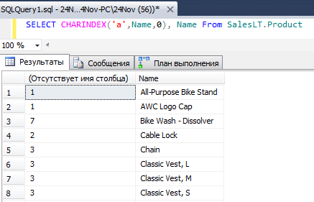

# **Ltrim**

**10. Get FIRST_NAME from employee table after removing white spaces from left side**

select LTRIM(FIRST_NAME) from employee

# Length

SELECT len(Name),Name From SalesLT.Product

# Replace

select REPLACE(FIRST_NAME,'o','$') from employee

# Two column in one

SELECT Color +'-'+Name From SalesLT.Product

# Order two columns

**Get all employee details from the employee table order by First_Name Ascending and Salary descending**

Select * from employee order by FIRST_NAME asc,SALARY desc

# Datetime to date

SELECT SellStartDate From SalesLT.Product Where CONVERT(date,SellStartDate) >'1999'